

“ FLIGHT PRICE PREDICTION”

Submitted by:

**RAHUL AHUJA**

**INTRODUCTION**

* Business Problem

Airline companies use complex algorithms to calculate flight prices given various conditions present at that particular time. These methods take financial, marketing, and various social factors into account to predict flight prices.

Nowadays, the number of people using flights has increased significantly. It is difficult for airlines to maintain prices since prices change dynamically due to different conditions. That’s why we will try to use machine learning to solve this problem. This can help airlines by predicting what prices they can maintain. It can also help customers to predict future flight prices and plan their journey accordingly.

* Conceptual Background of the Domain Problem

Anyone who has booked a flight ticket knows how unexpectedly the prices vary. The cheapest available ticket on a given flight gets more and less expensive over time. This usually happens as an attempt to maximize revenue based on –

1. Time of purchase patterns (making sure last-minute purchases are expensive)

2. Keeping the flight as full as they want it (raising prices on a flight which is filling up in order to reduce sales and hold back inventory for those expensive last-minute expensive purchases)

So, you have to work on a project where you collect data of flight fares with other features and work to make a model to predict fares of flights.

* Motivation for the Problem Undertaken

Below are the points/reasons for the below problem undertaken:

* To build a model using Machine Learning in order to predict the fares of the flights.
* To understand the purchase pattern of the flights.
* To find out the variables are important to predict the price of flights.
* To understand how do these variables describe the price of the flights.

**Analytical Problem Framing**

Data Sources and their formats

* The data has been scraped from the two websites from Makemytrip.com and Yatra.com. The Data has been gathered keeping base from Mumbai and Delhi
* Data contains 3010 entries each having 9 variables.
* Data contains no Null values.
* Data contains numerical as well as categorical variable.





* Data Pre-processing Done

Below are the steps taking for pre-processing and cleaning the data for the  
 analysis.

* The data has been scraped from MAKEMYTRIP.COM & YATRA.COM and downloaded data has been compiled in excel sheet in .CSV format.
* The data is on both object and the integer/float format
* The train data has total 3090 rows and 9 columns.
* There are no null values in data.
* Most of the data/columns are object type so we have to convert them into the integer format.
* There is some skewness in data which is removed in processing model
* The outliers are available in the data in Price and Duration column which has been removed before processing the Model.
* Rectified the string data for visualization.
* Used Label Encoder for converting the object data into Integer for further analysis.

Data Inputs- Logic- Output Relationships

The data has been categorized into two and that has been given x and y.

y data contains the columns (Fare Price of the flight).

x data contains the complete data which includes Airline Name, Departure time, arrival time, source and destination locations, duration of the flight, total stops in the flight and date of the journey.

**Model/s Development and Evaluation**

* Identification of possible problem-solving approaches (methods)

Visualizations

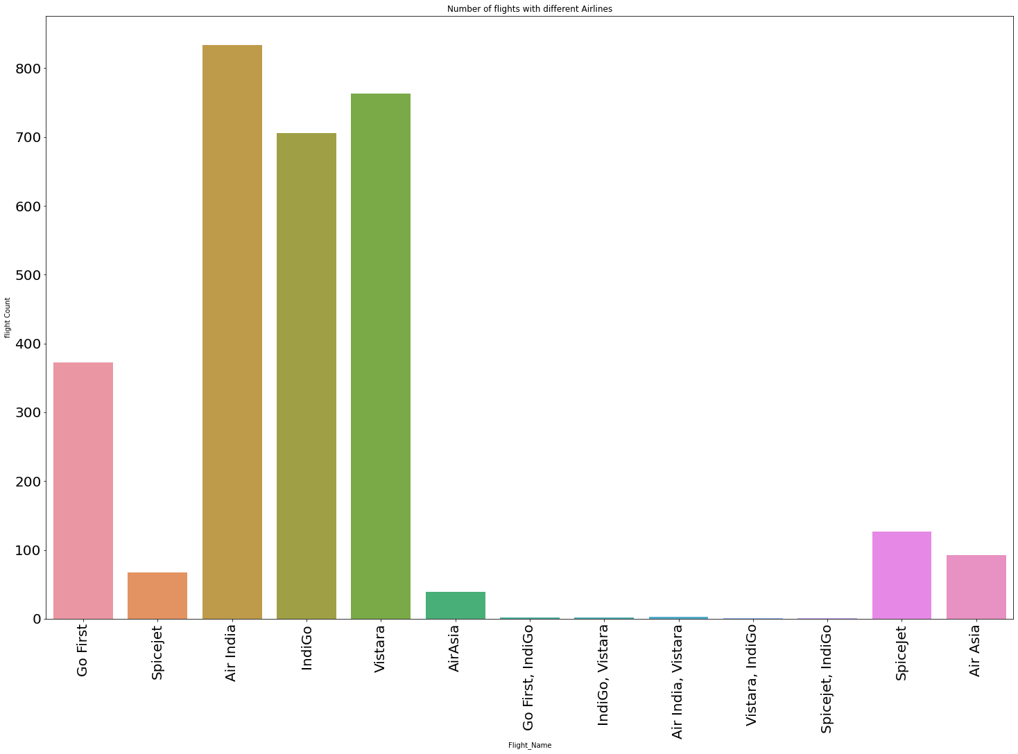

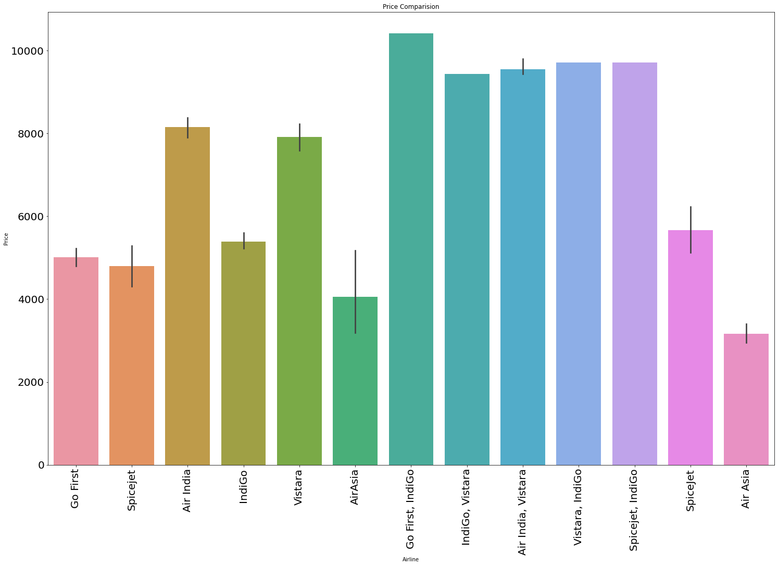

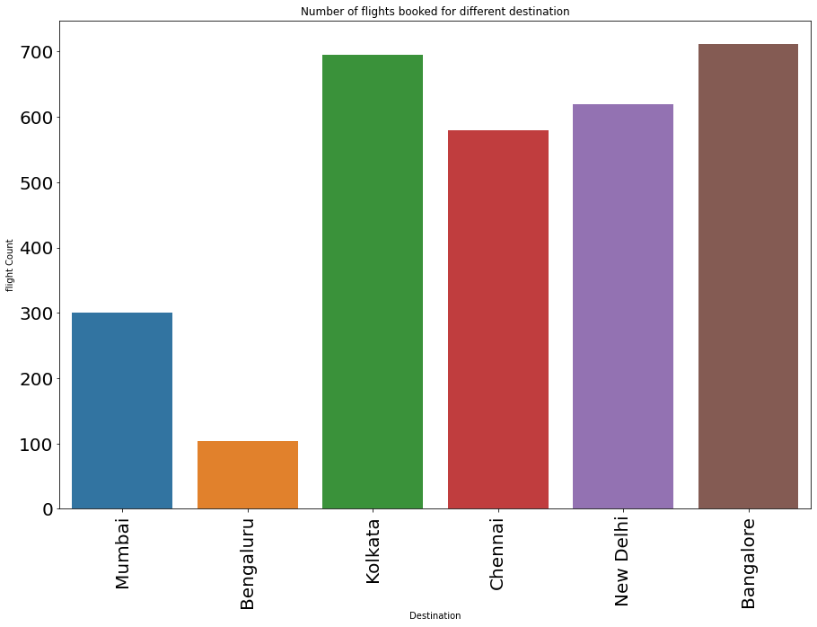

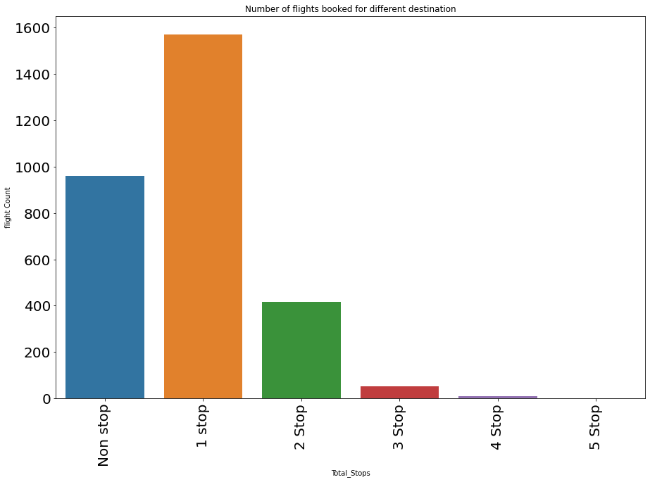

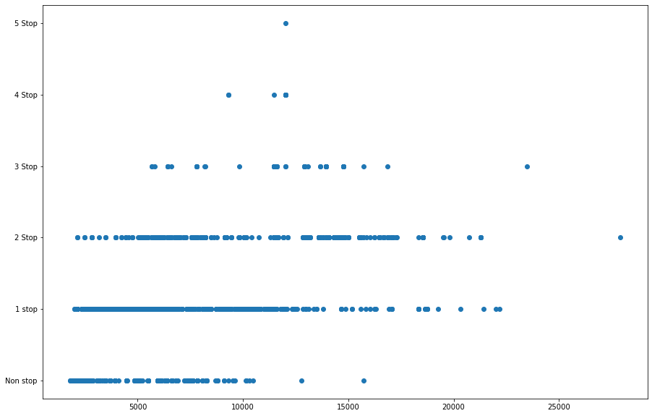

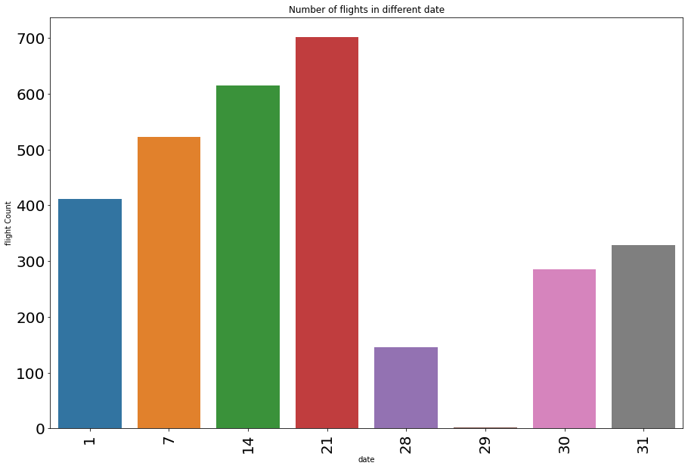

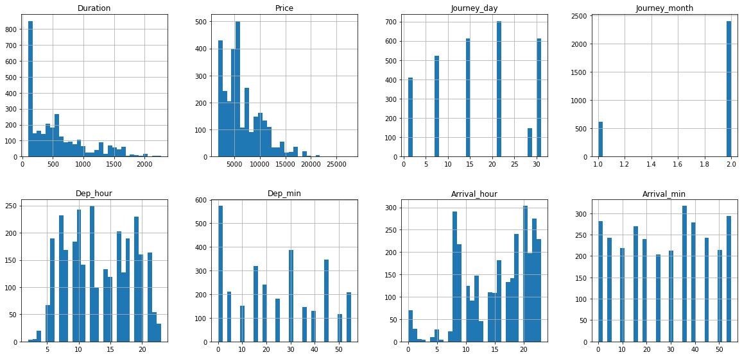

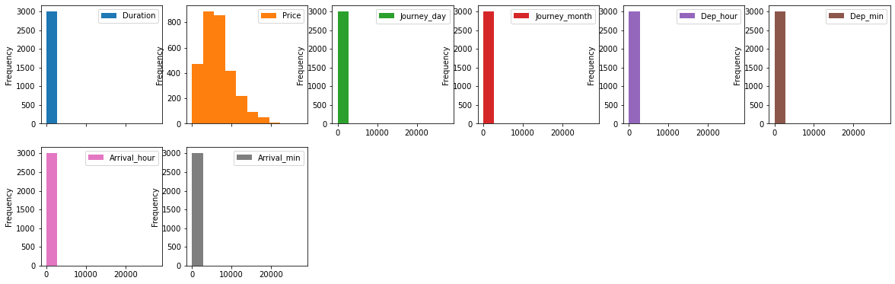

**Skewness:-**

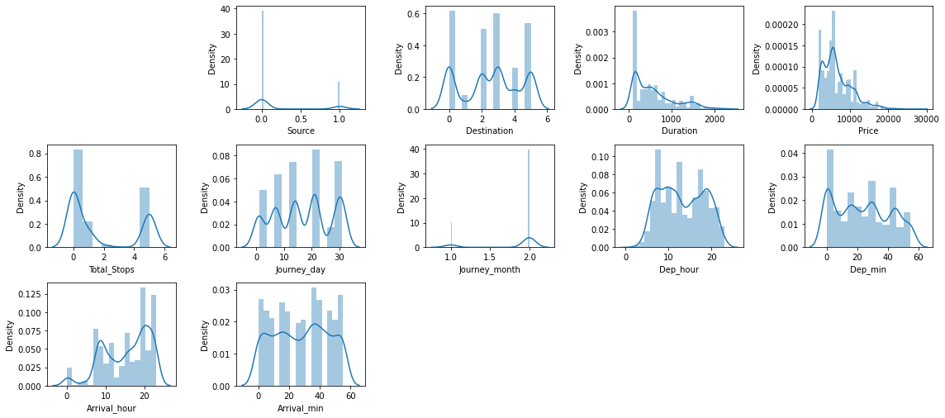

**Outliers:-**

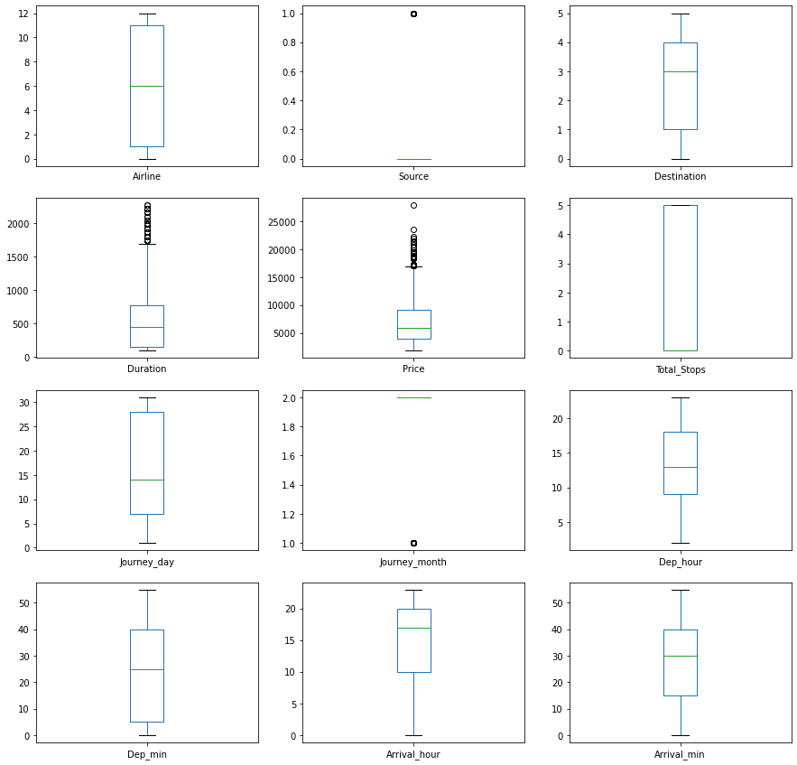

* Key Findings of the study

1. Air-india is the popular airlines among all other. Vistara is the 2nd most popular one.
2. Bangalore and Delhi is the preferred location.
3. Airline companies preferred to make 1 stop flights as it helps to go economical.
4. The prices got increase with the stoppage increase.
5. As we increases the range of dates the prices starts decreasing. So it has a negative correlation.

* Conclusions of the Study

Below is the conclusion.

After refining the data we have tested different models like Linear Regression,   
 SVR, Decision Tree Regressor, K Neighbors Regressor, Random Forest Regressor,   
 Ada Boost Regressor and the Gradient Boosting Regressor and after doing the   
 hypermetric tuning we have found that the Random Forest Regressor has   
 provided the best result.   
 The score of the same is mention below.





**Below is the actual data v/s prediction data**

